Bruntsfield Community Greengrocer Limited | 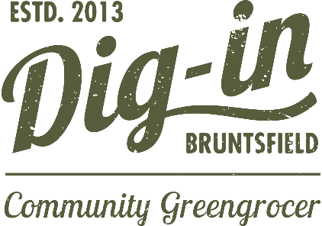
APPLICATION TO REQUEST A REFUND OF SHARES

*Required Fields
SECTION A
I/we wish to request a refund of my/our shares in Bruntsfield Community Greengrocer Limited, which is trading as Dig-In.
Name/s:*
Address: (house name or number, street, town and region)*
Postcode:*
Mobile:*
Landline:
E-mail:*
Number of shares held at £25 each:* |  | Total value of shares held (x £25):*
 |  | £
Share certificate number: |  | Date of issue:
Reason for requesting a refund:*
SECTION B - Payment Details
Your bank details to pay your refund into:
Account name:*
Account Number:*
Sort Code:*
Note: Data protection and money laundering
The data provided by you on this form will be stored within a computerised database. The data will only be used for Bruntsfield Community Greengrocer purposes and will not be disclosed to a third party. It is also a term of the request for a refund of shares that, in order to ensure compliance with the Money Laundering Regulations, Bruntsfield Community Greengrocer Limited may, at its absolute discretion, require verification of identity from the applicant.
SECTION C - Confirmations
- I have read and understood the Rules: https://www.diginbruntsfield.co.uk/get-involved/become-a-shareholder/ * Yes
- I understand that my/our request for the refund of shares is at the discretion of the Management Committee and will normally be considered as laid out in the Membership Strategy. * Yes
- I agree that Bruntsfield Community Greengrocer may communicate with me/us by electronic means at the following email address, via email and via its web site Yes
E-mail address:
- If you would prefer communication by another means please specify:
- I/we hereby confirm that all details on this form are correct to the best of my/our knowledge * Yes
I/we confirm that Bruntsfield Community Greengrocer Limited may hold the personal data submitted in this application in accordance with the Data Protection Act * Yes
- I/we confirm that Bruntsfield Community Greengrocer may seek to confirm my identity if my/our investment amounts to £10,000 or more * Yes
Date:*

Signature/s:*
Please email the completed form to secretary@digInbruntsfield.co.uk or drop it into the shop at Dig-in Bruntsfield, 119 Bruntsfield Place, EH10 4EQ.

