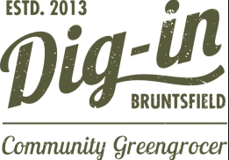
JOB
OPPORTUNITY
Shop Supervisor (Part time)
- Ensure the smooth daily running of our eco-friendly shop
- Supervise volunteers
- Maintain high quality customer service
10-16 hours/week * £10.00/hour * Saturdays/ad-hoc relief shifts
If you have the skills/experience, and want to be part of our community and climate friendly initiative - then please apply! Ask in shop or see diginbruntsfield.co.uk for full description (coming soon). Send your CV and cover letter to shop@diginbruntsfield.co.uk, email us or call 07493 747943 for a chat! Closing Date: Monday 16 May 5pm

