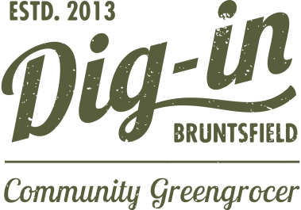
One-off Fruit and Veg Bag

Order Form

Our Fruit and Veg bags are carefully hand-picked for you by our dedicated team of staff and community volunteers.
What size of bag would you like?
Individual Bag (7 items of Veg plus 2 Fruit) £8+£2(*) ☐
Couples Bag (9 items of Veg plus 3 Fruit) £16+£2(*) ☐
Family Bag (11 items of Veg plus 3 Fruit) £24+£4(*) ☐
Extras:
Free-Range Organic Eggs (Mixed Sizes) £1.87 for a box of 6 . Boxes

(*) One-off bags include a charge of £2 to cover the cost of the jute bag, if you return the bag, we will credit your next order.

When would you like to collect it?

- Thursday 5-7pm ☐
- Friday 2-5pm ☐
- Friday 5-7pm ☐
- Saturday 10am-1pm ☐
- Saturday 1-3pm ☐
- Saturday 3-5pm ☐
What date would you like to collect your Fruit and Veg Bag?
Order Deadline: Monday noon for weekend deliveries

Paying for your veg

The easiest way to pay for your Fruit and Veg Bag is via our supporters account, that way you can just pop in, grab your bag and go.
If you already have a supporters account please tick here ☐ to authorise us to debit your account.

To open an account, see our website for more details, or ask in the shop. If you haven’t opened an account yet – no worries, simply pay for your veg bag at the till when you collect it.

Name: |  | Email:
Phone: |  | Signed:

Please e-mail this form to info@diginbruntsfield.co.uk or pop in to the shop

Thank you for your order

We’d love to keep you up to date with our latest news. If you’d like to receive our newsletter please tick here ☐
Dig-in 119 Bruntsfield Place Edinburgh, Scotland EH10 4EQ

